# *Development Project I (420-E50-HR)*

# *Assignment 8 – Solution Architecture and Technical Recommendations*

Date assigned: Monday, October 5, 2017

Date due: **Thursday, October 8, 2017, 11:55 p.m.**

**Computer Science late policy applies.**

**This assignment is required for the PEA.**

**Learning Objectives**

Upon successful completion of this assignment, the student will be able to:

* Describe and compare the architectures of a variety of existing systems
* Describe the advantages and disadvantages of using stored procedures
* Recommend a technical architecture for ASP.NET
* Recommend an approach to be used with the Entity Framework
* Recommend how a system should be tested

**To do:**

This assignment consists of individual activities. Save this document with the name **YourUserName_E50_A08_ Architecture.docx** in your folder for this course.

Note: These solutions run against the csdev SQL server. Do NOT modify any of the data in the database. You’re just here to investigate and learn.

**Warning**: This assignment requires research and figuring things out. There are some big projects you will be required to look at and some with infrastructures that you may not be familiar with. You may be lost at first. Try and if you’re stuck ask your peers or your prof for help.

**Part A – Solution Architecture for System 1 (CSADMIN)**

The CSAdmin application was built to handle functionality that is common to the applications built by the third year Computer Science projects. In particular, it handles authentication and authorization for systems involving external users and authorization for internal users. It also handles the maintenance and storage of data that is common to more than one application, such as countries and provinces.

1. Open Visual Studio 2015. Select Team, Manage Connections… from the menu bar. In the Team Explorer, select Connect to Team Projects and click ***Select Team Projects***. Ensure that the Team Foundation Server is cstfs.cegep-heritage.qc.ca in the drop down and that the Team Project Collections are displayed. Select the ***CSAdmin*** Team Project Collection and the CSAdmin Team Project and select Connect. Select ***configure your workspace*.** Use the default values in the text boxes andselect ***Map & Get***. Click on the CSAdmin solution that is displayed in the CSAdmin branch.
2. Examine the organization of the solution using the Solution Explorer. List the projects that are in the solution.

CSAdmin and CSAdminCode

1. Select Architecture, Generate Code Map for Solution from the menu. Expand CSAdminCode.dll. Select Share, Copy Image and paste the Code Map below. Close the Code Map without saving it.

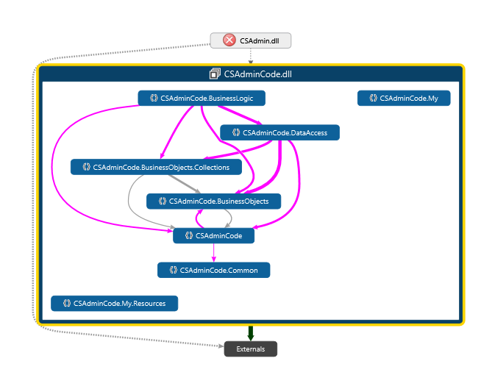

1. Set a breakpoint in the first line in the page load of the Manage Languages page. Run the application, logging in with the username *userad* (for User Administrator) and the password the same as the username. In the debugger, select ***Show Call Stack on Code Map***to generate a diagram which depicts the relationships in the code as you step through the code. Step through the code until the page displays. In the diagram select (right click) ***Show Containing Type, Name, and Assembly*** (do this on one of the children of the trace tree). Paste the Code Map below. Close the Code Map without saving it. (I should see all the functions used between the breakpoint and the page display including how the languages were loaded).

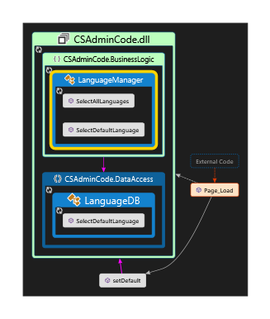

1. List the main programming languages used in the application.

**The application uses: VisualBasic, ASPX XML, JavaScript, CSS, SQL**

1. Determine the approach used to access the language data of the “Managing Languages page”. Explain how the language data are loaded from the database. (Hint: you will need to use MS SQL Server Management Studio to figure this out.). Does the application need to know the tables and schema for how languages are stored in the database? (ORM vs SQL, if SQL what kind of queries/invocation? )

**The application does not need to know about how the database stores the information in the backend, the application needs to only make called to the stored procedures in the database.**

1. Indicate which .NET model that is used (i.e. Web Forms or MVC). If it is Web Forms, describe how the five layers commonly used for a layered architecture are implemented in the application and indicate what type(s) of data source controls are used.

**Web Forms:**

* **Data Tier:** 
  + **The data is stored in the SQL Server database**
* **Data Access layer**
  + **The Data Access layer makes calls to stored procedures in the database and then convert the data returned into classes**
* **Business Logic layer**
  + **There’s classes in the business logic layer that contain all of the business logic for each of the different business objects.**
* **Presentation logic** 
  + **This is the code-behind on each of the aspx pages**
* **Presentation Layer**
  + **The aspx page containing all of the xml that is translated to HTML and output to the browser.**

**Part B – Solution Architecture for System 2 (APTS)**

Hint: you will have to cleanup your connection strings. Here’s what worked for me.

In Visual Studio 2015, connect to the **APTS** Project Collection and the APTS Team Project.

1. Examine the organization of the solution using the Solution Explorer. List the projects that are in the solution.

**APTS**

**APTS.Tests**

1. Select Architecture, Generate Code Map for Solution from the menu. Expand APTS.dll and APTS.Tests.dll. Select Share, Copy Image and paste the Code Map below. Close the Code Map without saving it.

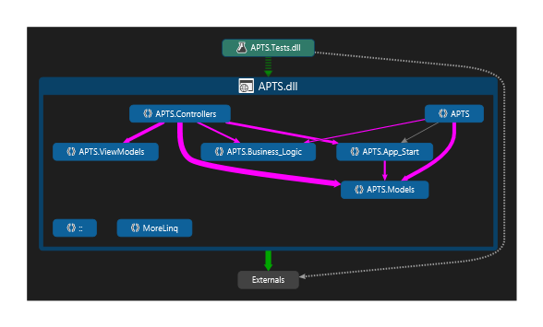

1. After you login, Click on the “Students” “See students who have filled out academic probation contracts”. Run the application until the page data is retrieved. Figure out where this retrieval happens in the code. In the debugger, select ***Show Call Stack on Code Map***. Step through the code until the page data is loaded. In the diagram select ***Show Containing Type, Name, and Assembly***. Paste the Code Map below. Close the Code Map without saving it. Hint.

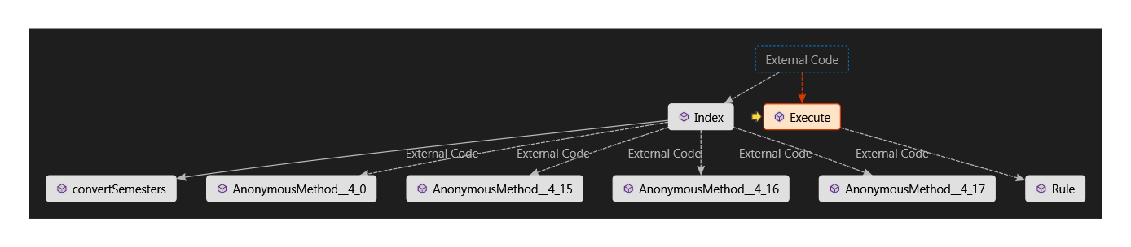

1. Explain how the student information is loaded from the database. Does the application need to know the tables and schema for how students are stored in the database? What is the basic approach being used here (ORM vs SQL )?

**Yes, the application needs to know how all of that information is stored in the database. The application has an edmx file that contains the database model and that edmx is referenced by table name in the C# files when accessing data from a table.**

1. Figure out how the “userad” is authenticated and authorized. Explain. What infrastructure is being used to authenticate? What’s your first entry point from the time the login button is pressed until you are authenticated? Show me the call stack:

The userad is authorized from active directory. In the AccountController.cs class there is a Login function that makes a call to Membership.ValidateUser, and the membership object comes from the web.config file under a system.web object

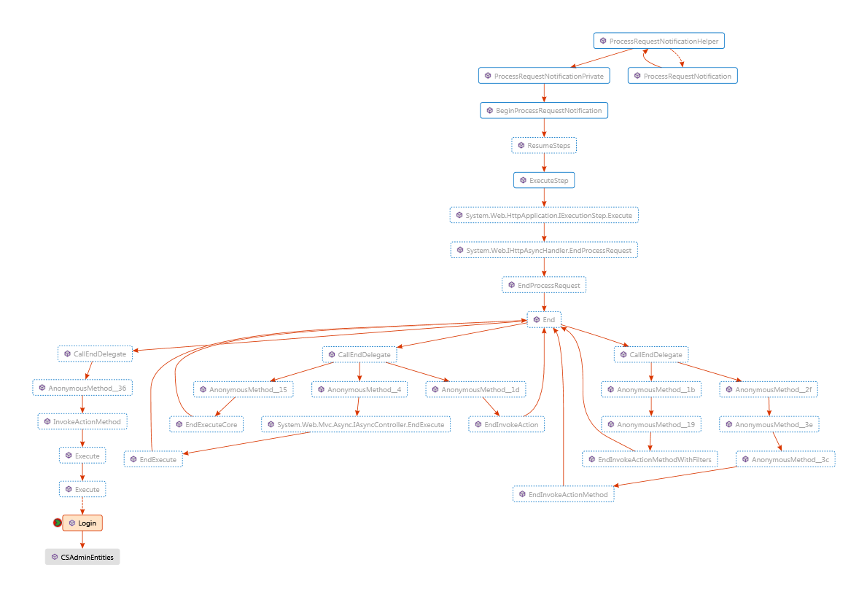

1. List the main programming languages used in the application.

**C#, HTML, CSS, JavaScript, SQL**

**The data is accessed through the Entity data model object that contains the information about all of the data tables that exist in the database.**

1. Indicate which .NET model that is used (i.e. Web Forms or MVC). If it is Web Forms, describe how the five layers commonly used for a layered architecture are implemented in the application and indicate what type(s) of data source controls are used.

**MVC**

**Part C – Solution Architecture for System 3 (FACE)**

In Visual Studio 2015, connect to the **FACE** Project Collection.

1. Examine the organization of the solution using the Solution Explorer. List the projects that are in the solution.

**FACEWeb**

**FACECode**

**Face.Test**

1. After you login, list the programs, select the 2016 Microsoft Network and Security Administrator program, check all cohorts and click on Display.

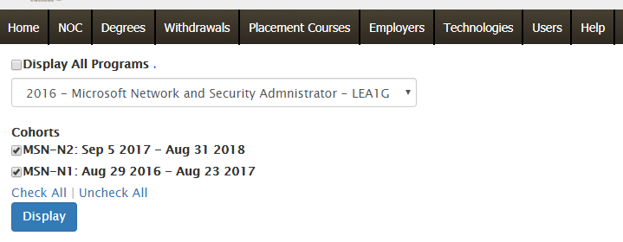

Figure out where this retrieval happens in the code. In the debugger, select ***Show Call Stack on Code Map***. Step through the code until the page displays. In the diagram select ***Show Containing Type, Name, and Assembly***. Paste the Code Map below. Close the Code Map without saving it.

1. Explain how the student information is loaded from the database. Does the application need to know the tables and schema for how students are stored in the database? What is the basic approach being used here and what infrastructure?
2. Figure out how the “userad” is authenticated and authorized. Explain. What infrastructure is being used to authenticate? What’s your first entry point from the time the login button is pressed until you are authenticated? Show me the call stack:

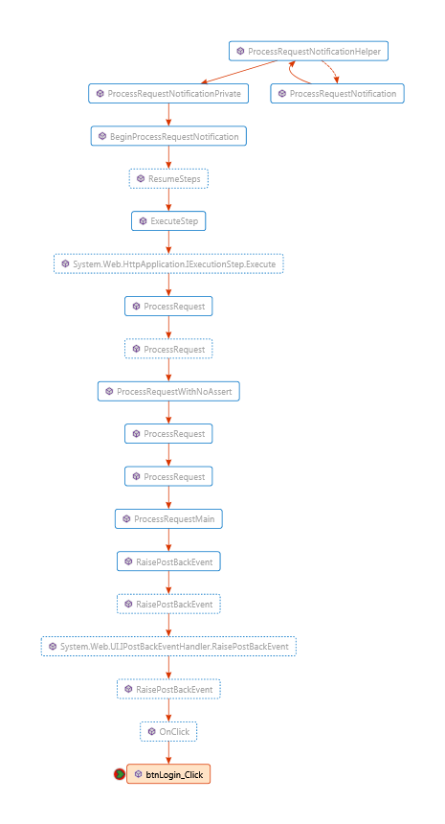

1. This application retrieves data from Clara. Figure out how it does this and explain the approach. Find a workflow that does this and show me the call stack:

**It uses a synonym of Clara in the SQL Server database.**

1. List the main programming languages used in the application.

**C#, HTML, CSS, JavaScript**

1. Indicate which .NET model that is used (i.e. Web Forms or MVC). If it is Web Forms, describe how the five layers commonly used for a layered architecture are implemented in the application and indicate what type(s) of data source controls are used.

**Web Forms:**

* **Data Tier:** 
  + **The data is stored in CSDEV in the FACE database**
* **Data Access layer**
  + **The Data Access layer makes calls to stored procedures in the database and then convert the data returned into classes**
* **Business Logic layer**
  + **There’s classes in the business logic layer that contain all of the business logic for each of the different business objects.**
* **Presentation logic** 
  + **This is the code-behind on each of the aspx pages**
* **Presentation Layer**
  + **The aspx page containing all of the xml that is translated to HTML and output to the browser.**

**Part D – Comparison of Solutions**

1. Compare the organization of the solutions in the three applications, describing the main similarities and differences. Put together a summary table showing the key attributes of each solution for comparison.

|  |  |  |  |
| --- | --- | --- | --- |
|  | **CSADMIN** | **APTS** | **FACE** |
| **WebForms** | **There’s two projects. One with the business logic, business object, and data access, and then one that contains just the aspx pages and no actual logic.** |  | **Has a solution containing BuisnessObjects and DataAccess, and then a web solution with the Business Logic and UI files. There’s also a third Solution with tests.** |
| **MVC** |  | **The only one using the MVC model.** |  |

**Part E – Business Logic**

1. Research the advantages and the disadvantages of using stored procedures compared to using an Object Relational Mapper (ORM) such as Entity Framework. In your own words, identify the three main advantages and the three main disadvantages.

**ORM**

Advantages:

* One advantage to using an ORM is that if you end up porting your database to another tool, you don’t need to change any of your code. The queries you’re writing will stay the same unless it’s to a non-SQL dialect of database.
* Another advantage to ORMs is that all the code is in the same place. The code to retrieve that data isn’t sitting on an entirely separate system.
* Using an ORM loosens the coupling between the database and the system.

Disadvantages:

* One disadvantage to ORMs is that they’re slower than a storied procedure. Once you have more than just a very basic CRUD command, the ORMs are too slow.
* ORMs require your developer to know how the database works, understand the relationships and know the language
* ORMs also can look messy inside your code when written as strings. C# has LINQ, which improves that, but overall it’s messy in your code.

**Stored Procedures**

Advantages:

* Stored procedures are very efficient. The database is able to optimize the query much better than any external source and running multi-table joins is very efficient.
* The stored procedures are compiled in the database, meaning that every time you call them you don’t need to recompile or interpret the procedure. This ties in partly to them being so fast.
* Your code doesn’t need to know how the database works in the back end. It doesn’t need to know what all the tables are or anything, so this creates a level of abstraction between the database and the code.

Disadvantages:

* If you change database systems, your stored procedures likely need to be re-written to an entirely new dialect of SQL.
* You need to have a couple more good database guys, which are harder to come by than developers.
* Your stored procedures are much more rigid and don’t allow you to the same kind of flexibility that ORMs do. You need to pass your data around a bit more before you can do anything with it.

1. Include the references that were used in completing the assignment

[**https://stackoverflow.com/questions/5346601/stored-procedures-and-orms#5346660**](https://stackoverflow.com/questions/5346601/stored-procedures-and-orms#5346660)

[**http://sqlblog.com/blogs/paul_nielsen/archive/2009/05/09/why-use-stored-procedures.aspx**](http://sqlblog.com/blogs/paul_nielsen/archive/2009/05/09/why-use-stored-procedures.aspx)

[**http://eichler.byethost11.com/misc/AntiSP.htm?i=1**](http://eichler.byethost11.com/misc/AntiSP.htm?i=1)

[**http://www.yegor256.com/2014/12/01/orm-offensive-anti-pattern.html**](http://www.yegor256.com/2014/12/01/orm-offensive-anti-pattern.html)

**Part F – Recommendation**

1. The technical environment for the system being developed is the Computer Science Department standard, which is an ASP.NET application using Entity Framework and SQL Server as the database. This assignment involves analyzing various options related to the technical environment. Using an appropriate format, write a report containing an Introduction, Body, and Conclusion, and addressing the following items:
   1. **The technical architecture to be used for ASP.NET:**   
      Briefly describe the two main approaches that can be used in ASP.NET to develop the applications. In your own words, describe the advantages and disadvantages of each one with respect to the system being developed. Recommend the most appropriate technique to be used for the system.
   2. **The approaches for using the Entity Framework:**Describe the development approaches that can be used for the Entity Framework and recommend the most appropriate technique. Justify your recommendation.
   3. **The options for testing:**   
      Research and document the options for testing the system based on the recommended technical architecture. Recommend the most appropriate approach for testing the system.
   4. All the references that were used.

**To submit**

When you have completed the assignment, zip your files together and submit it to Moodle.

You should have the following in your submission:

1. **YourUserName_E50_A08_Architecture.docx** with the answers to Parts A-E filled in

2. **YourUserName_E50_A08_TechRecommendationReport.docx** (Part F)